**Spring Core Maven**

**Exercise 1: Configuring a Basic Spring Application**

**pom.xml**

<project xmlns="http://maven.apache.org/POM/4.0.0" xmlns:xsi="http://www.w3.org/2001/XMLSchema-instance" xsi:schemaLocation="http://maven.apache.org/POM/4.0.0 https://maven.apache.org/xsd/maven-4.0.0.xsd">

<modelVersion>4.0.0</modelVersion>

<groupId>com.library</groupId>

<artifactId>LibraryManagement</artifactId>

<version>0.0.1-SNAPSHOT</version>

<name>LibraryManagement</name>

<dependencies>

<dependency>

<groupId>org.springframework</groupId>

<artifactId>spring-context</artifactId>

<version>5.3.34</version>

</dependency>

</dependencies>

</project>

**BookRepository.java**

package com.library.repository;

public class BookRepository {

public void saveBook(String bookName) {

System.out.println("Book saved: " + bookName);

}

}

**BookService.java**

package com.library.service;

import com.library.repository.BookRepository;

public class BookService {

private BookRepository bookRepository;

// Setter for injection

public void setBookRepository(BookRepository bookRepository) {

this.bookRepository = bookRepository;

}

public void addBook(String bookName) {

System.out.println("Adding book: " + bookName);

bookRepository.saveBook(bookName);

}

}

**MainApp.java**

package com.library;

import com.library.service.BookService;

import org.springframework.context.ApplicationContext;

import org.springframework.context.support.ClassPathXmlApplicationContext;

public class MainApp {

public static void main(String[] args) {

ApplicationContext context = new ClassPathXmlApplicationContext("applicationContext.xml");

BookService bookService = (BookService) context.getBean("bookService");

bookService.addBook("The Great Gatsby");

}

}

**applicationContext.xml**

<?xml version="1.0" encoding="UTF-8"?>

<beans xmlns="http://www.springframework.org/schema/beans"

xmlns:xsi="http://www.w3.org/2001/XMLSchema-instance"

xsi:schemaLocation="

http://www.springframework.org/schema/beans

http://www.springframework.org/schema/beans/spring-beans.xsd">

<bean id="bookRepository" class="com.library.repository.BookRepository"/>

<bean id="bookService" class="com.library.service.BookService">

<property name="bookRepository" ref="bookRepository"/>

</bean>

</beans>

**Output:**

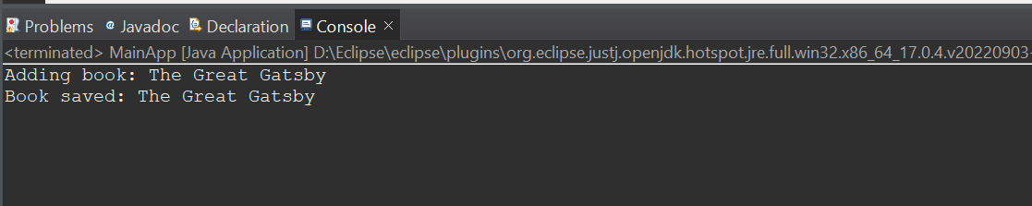

**Exercise 2: Implementing Dependency Injection**

**applicationContext.xml**

<?xml version="1.0" encoding="UTF-8"?>

<beans xmlns="http://www.springframework.org/schema/beans"

xmlns:xsi="http://www.w3.org/2001/XMLSchema-instance"

xsi:schemaLocation="

http://www.springframework.org/schema/beans

https://www.springframework.org/schema/beans/spring-beans.xsd">

<!-- BookRepository Bean -->

<bean id="bookRepository" class="com.library.repository.BookRepository"/>

<!-- BookService Bean with Dependency Injection -->

<bean id="bookService" class="com.library.service.BookService">

<property name="bookRepository" ref="bookRepository"/>

</bean>

</beans>

**BookService.java**

package com.library.service;

import com.library.repository.BookRepository;

public class BookService {

private BookRepository bookRepository;

// Setter Injection

public void setBookRepository(BookRepository bookRepository) {

this.bookRepository = bookRepository;

}

public void addBook(String bookName) {

System.out.println("Adding book: " + bookName);

bookRepository.saveBook(bookName);

}

}

**BookRepository.java**

package com.library.repository;

public class BookRepository {

public void saveBook(String bookName) {

System.out.println("Book saved: " + bookName);

}

}

**MainApp.java**

package com.library;

import com.library.service.BookService;

import org.springframework.context.ApplicationContext;

import org.springframework.context.support.ClassPathXmlApplicationContext;

public class LibraryManagementApplication {

public static void main(String[] args) {

ApplicationContext context = new ClassPathXmlApplicationContext("applicationContext.xml");

BookService bookService = (BookService) context.getBean("bookService");

bookService.addBook("Spring in Action");

}

}

**Output:**

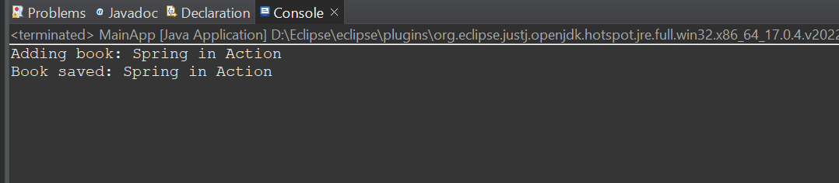

**Exercise 4: Creating and Configuring a Maven Project**

**pom.xml**

<project xmlns="http://maven.apache.org/POM/4.0.0"

xmlns:xsi="http://www.w3.org/2001/XMLSchema-instance"

xsi:schemaLocation="http://maven.apache.org/POM/4.0.0

http://maven.apache.org/xsd/maven-4.0.0.xsd">

<modelVersion>4.0.0</modelVersion>

<groupId>com.library</groupId>

<artifactId>LibraryManagement</artifactId>

<version>1.0-SNAPSHOT</version>

<packaging>jar</packaging>

<name>LibraryManagement</name>

<dependencies>

<dependency>

<groupId>org.springframework</groupId>

<artifactId>spring-context</artifactId>

<version>5.3.34</version>

</dependency>

<dependency>

<groupId>org.springframework</groupId>

<artifactId>spring-aop</artifactId>

<version>5.3.34</version>

</dependency>

<dependency>

<groupId>org.springframework</groupId>

<artifactId>spring-webmvc</artifactId>

<version>5.3.34</version>

</dependency>

<dependency>

<groupId>javax.servlet</groupId>

<artifactId>javax.servlet-api</artifactId>

<version>4.0.1</version>

<scope>provided</scope>

</dependency>

</dependencies>

<build>

<plugins>

<plugin>

<groupId>org.apache.maven.plugins</groupId>

<artifactId>maven-compiler-plugin</artifactId>

<version>3.8.1</version>

<configuration>

<source>1.8</source>

<target>1.8</target>

</configuration>

</plugin>

</plugins>

</build>

</project>

**Spring Data JPA - Quick Example**

**application.properties**

# Logging levels

logging.level.org.springframework=info

logging.level.com.cognizant=debug

logging.level.org.hibernate.SQL=trace

logging.level.org.hibernate.type.descriptor.sql=trace

# Console log format

logging.pattern.console=%d{dd-MM-yy} %d{HH:mm:ss.SSS} %-20.20thread %5p %-25.25logger{25} %25M %4L %m%n

# Database Configuration

spring.datasource.driver-class-name=com.mysql.cj.jdbc.Driver

spring.datasource.url=jdbc:mysql://localhost:3306/ormlearn

spring.datasource.username=root

spring.datasource.password=root

# Hibernate

spring.jpa.hibernate.ddl-auto=validate

spring.jpa.properties.hibernate.dialect=org.hibernate.dialect.MySQL5Dialect

**sql**

CREATE DATABASE ormlearn;

USE ormlearn;

CREATE TABLE country (

code VARCHAR(2) PRIMARY KEY,

name VARCHAR(50)

);

INSERT INTO country VALUES ('IN', 'India');

INSERT INTO country VALUES ('US', 'United States of America');

**Country.java**

package com.cognizant.ormlearn.model;

import javax.persistence.*;

@Entity

@Table(name = "country")

public class Country {

@Id

@Column(name = "code")

private String code;

@Column(name = "name")

private String name;

// Getters and Setters

public String getCode() {

return code;

}

public void setCode(String code) {

this.code = code;

}

public String getName() {

return name;

}

public void setName(String name) {

this.name = name;

}

@Override

public String toString() {

return "Country [code=" + code + ", name=" + name + "]";

}

}

**CountryRepository.java**

package com.cognizant.ormlearn.repository;

import org.springframework.data.jpa.repository.JpaRepository;

import org.springframework.stereotype.Repository

import com.cognizant.ormlearn.model.Country;

@Repository

public interface CountryRepository extends JpaRepository<Country, String> {

}

CountryService.java

package com.cognizant.ormlearn.service;

import java.util.List;

import org.springframework.beans.factory.annotation.Autowired;

import org.springframework.stereotype.Service;

import org.springframework.transaction.annotation.Transactional;

import com.cognizant.ormlearn.model.Country;

import com.cognizant.ormlearn.repository.CountryRepository;

@Service

public class CountryService {

@Autowired

private CountryRepository countryRepository;

@Transactional

public List<Country> getAllCountries() {

return countryRepository.findAll();

}

}

**OrmLearnApplication.java**

package com.cognizant.ormlearn;

import java.util.List;

import org.slf4j.Logger;

import org.slf4j.LoggerFactory;

import org.springframework.boot.SpringApplication;

import org.springframework.boot.autoconfigure.SpringBootApplication;

import org.springframework.context.ApplicationContext;

import com.cognizant.ormlearn.model.Country;

import com.cognizant.ormlearn.service.CountryService;

@SpringBootApplication

public class OrmLearnApplication {

private static final Logger LOGGER = LoggerFactory.getLogger(OrmLearnApplication.class);

private static CountryService countryService;

public static void main(String[] args) {

ApplicationContext context = SpringApplication.run(OrmLearnApplication.class, args);

countryService = context.getBean(CountryService.class);

testGetAllCountries();

}

private static void testGetAllCountries() {

LOGGER.info("Start");

List<Country> countries = countryService.getAllCountries();

LOGGER.debug("countries={}", countries);

LOGGER.info("End");

}

}

**Output:**

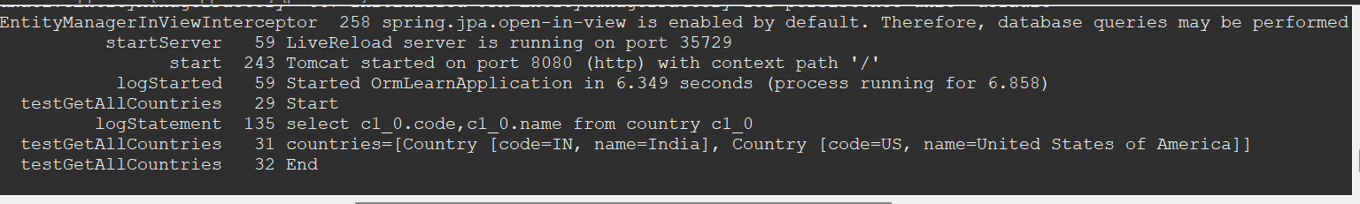

**Difference between JPA, Hibernate and Spring Data JPA   
Employee.java**

package com.example.model;

import jakarta.persistence.*;

@Entity

public class Employee {

@Id

@GeneratedValue(strategy = GenerationType.IDENTITY)

private Integer id;

private String name;

private double salary;

public Employee() {}

public Employee(String name, double salary) {

this.name = name;

this.salary = salary;

}

// Getters and Setters

public Integer getId() { return id; }

public String getName() { return name; }

public double getSalary() { return salary; }

public void setId(Integer id) { this.id = id; }

public void setName(String name) { this.name = name; }

public void setSalary(double salary) { this.salary = salary; }

}

**HibernateExample.java**

package com.example.hibernate;

import com.example.model.Employee;

import org.hibernate.*;

import org.hibernate.cfg.Configuration;

public class HibernateExample {

private static SessionFactory factory;

public static void main(String[] args) {

factory = new Configuration().configure("hibernate.cfg.xml")

.addAnnotatedClass(Employee.class)

.buildSessionFactory();

Employee emp = new Employee("John", 50000);

addEmployee(emp);

}

public static void addEmployee(Employee employee){

Session session = factory.openSession();

Transaction tx = null;

Integer employeeID = null;

try {

tx = session.beginTransaction();

employeeID = (Integer) session.save(employee);

tx.commit();

System.out.println("Employee saved using Hibernate: " + employeeID);

} catch (HibernateException e) {

if (tx != null) tx.rollback();

e.printStackTrace();

} finally {

session.close();

}

}

}

**Output:**

Employee saved using Hibernate: 1

**JpaExampleService.java**

package com.example.jpa;

import com.example.model.Employee;

import jakarta.persistence.*;

import org.springframework.stereotype.Service;

import org.springframework.transaction.annotation.Transactional;

@Service

public class JpaExampleService {

@PersistenceContext

private EntityManager entityManager;

@Transactional

public void addEmployee(Employee employee) {

entityManager.persist(employee);

System.out.println("Employee saved using JPA: " + employee.getId());

}

}

**Output:**

Employee saved using JPA: 2

**EmployeeRepository.java**

package com.example.repository;

import com.example.model.Employee;

import org.springframework.data.jpa.repository.JpaRepository;

public interface EmployeeRepository extends JpaRepository<Employee, Integer> {}

**SpringDataJpaExample.java**

package com.example.service;

import com.example.model.Employee;

import com.example.repository.EmployeeRepository;

import org.springframework.beans.factory.annotation.Autowired;

import org.springframework.stereotype.Service;

import org.springframework.transaction.annotation.Transactional;

@Service

public class SpringDataJpaExample {

@Autowired

private EmployeeRepository employeeRepository;

@Transactional

public void addEmployee(Employee employee) {

employeeRepository.save(employee);

System.out.println("Employee saved using Spring Data JPA: " + employee.getId());

}

}

**Output:**

Employee saved using Spring Data JPA: 3